Lab1 Report – AWS EC2 VM Deployment
Name: ALI AMADOU
Course: Cloud Computing – GCYS2
Lab: Lab 1 – Create and access a VM in AWS

1. Objective
The objective of this lab was to deploy a simple web server on the internet using an EC2 instance in AWS. This involved:
- Creating a virtual machine (VM) in the cloud.
- Configuring SSH access.
- Installing and running a web server.
- Testing connectivity from a local machine.

2. Steps Performed

Step 1 – AWS Account Setup
- Created an AWS account using the Free Tier plan.
- Provided billing information (required even for free plan).

Step 2 – EC2 Instance Creation
- Selected EC2 service in AWS console.
- Launched a new instance using:
  - AMI: Amazon Linux
  - Instance type: t2.micro (Free Tier eligible)
- Created an RSA key-pair (cloud-lab-key.pem) for SSH access.

Step 3 – Network Configuration
- Checked Inbound rules in the Security Group:
  - SSH (port 22) open to all (0.0.0.0/0)
  - HTTP (port 80) open to all (0.0.0.0/0) to allow web traffic.
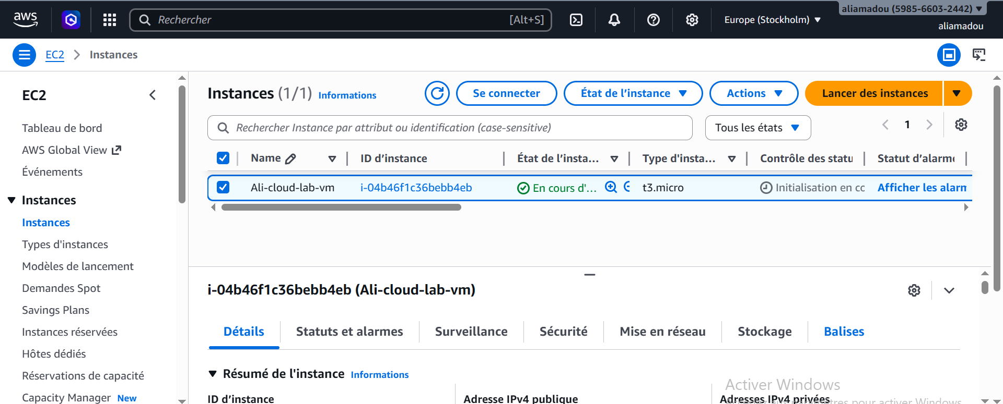

Step 4 – Connecting via SSH
- Connected from local machine using:
ssh -i cloud-lab-key.pem ec2-user@16.171.225.240
- Verified successful connection.
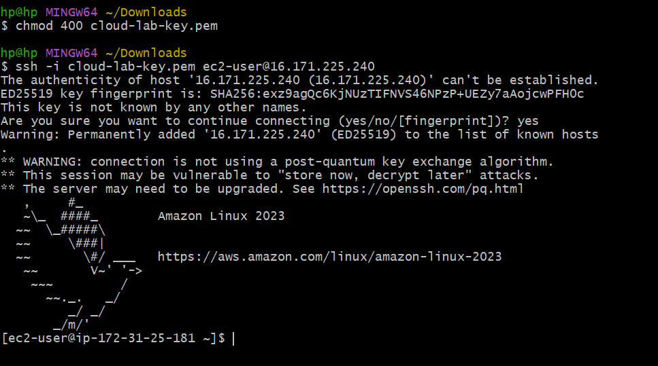

Step 5 – Installing Web Server
- Installed Nginx:
sudo dnf install nginx -y
sudo systemctl start nginx
sudo systemctl enable nginx
- Verified the server is running:
sudo systemctl status nginx
- Accessed the default page via browser:
http://16.171.225.240:


Step 6 – Deploying a Web Application
- Created a simple Node.js app:
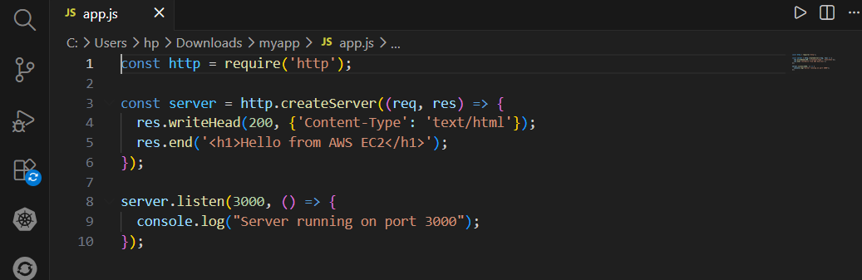
- Copied the application to the EC2 instance using scp in my terminal :
- Installed Node.js on the instance.
- Ran the app and accessed it via:
http://16.171.225.240:3000 → “Hello from AWS EC2”
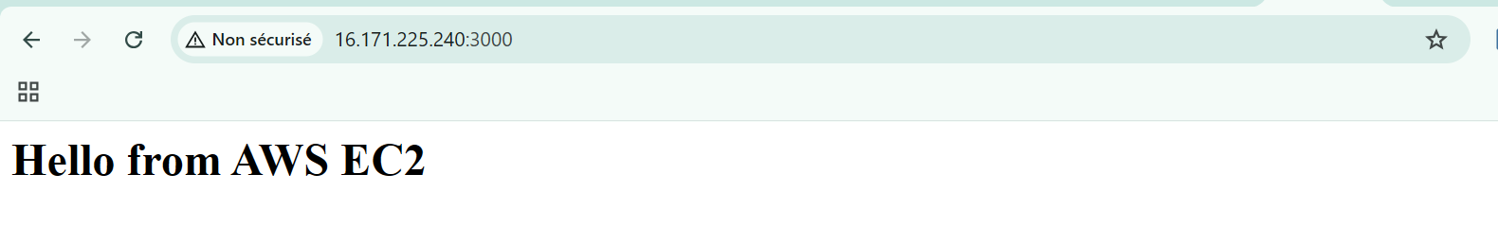

3. Results
- Successfully created and accessed an EC2 instance.
- Installed and configured Nginx to serve HTTP requests.
- Deployed a simple Node.js application and confirmed it works.
- Verified network connectivity and Security Group configuration.

4. Challenges and Solutions
1- chmod command not recognized on Windows so I used Git Bash instead of PowerShell to set file permissions.
2- HTTP access blocked initially so I Added port 80 rule in EC2 Security Group.

5. Conclusion
This lab demonstrated the process of deploying a cloud-based virtual server on AWS, connecting via SSH, installing a web server, and deploying a web application.

